**1. What are comments and what is the importance if commenting in any code?**

In programming, comments are lines of text that are written within the source code of a about the code, making it easier for programmers to understand and maintain the codebase.program but are ignored by the compiler or interpreter. They are used to add explanatory or descriptive information

Code Understanding and Readability: Comments provide additional context and explanations about the code. They help other developers (including yourself in the future) understand the purpose, logic, and functionality of the code. Well-commented code is more readable and reduces the time and effort required to comprehend the codebase.

Code Maintenance and Collaboration: When multiple developers work on a project, comments serve as a means of communication. They enable team members to understand each other's code and collaborate effectively. Comments can also provide insights into potential issues or future improvements, making maintenance and debugging easier.

Documentation: Comments can be used to generate documentation for the codebase. By following consistent commenting practices, you can automatically extract relevant information to create API documentation, user guides, or other forms of technical documentation. This makes it easier for others to use or integrate with your code.

Debugging and Troubleshooting: Well-placed comments can help identify and isolate bugs in the code. By temporarily disabling or adding debug information through comments, you can narrow down the problematic areas and track down the source of errors more efficiently.

**2. What is Call Statement and when do you use this statement?**

In programming, a call statement (also known as a function call or method invocation) is a statement that invokes a function or method to perform a specific action or computation. It is used to execute a sequence of code statements defined within the function or method being called.

A call statement typically consists of the name of the function or method being called, followed by parentheses that may contain arguments or parameters passed to the function. The arguments, if any, provide input values or data required by the function to perform its task.

Call statements are used whenever you want to execute a particular function or method and obtain the results or perform a specific action associated with that function. They are used to modularize code by breaking it down into smaller, reusable functions, which can be called multiple times from different parts of the program.

Code Reusability: By defining functions or methods and calling them when needed, you can reuse the same logic or functionality throughout your program. This promotes code modularity and helps avoid duplicating code.

Abstraction and Encapsulation: Call statements provide a way to abstract away complex or repetitive tasks by encapsulating them within functions or methods. This improves code organization, readability, and maintainability.

Code Structuring: Using call statements allows you to structure your program into smaller, manageable units of code. This makes the overall program structure more comprehensible and easier to maintain.

Parameter Passing: Call statements enable you to pass data or values as arguments to functions, allowing the functions to work with specific inputs and produce desired outputs. This facilitates customization and flexibility in the behavior of functions.

**3. How do you compile a code in VBA? What are some of the problem that you might face when you don’t compile a code?**

In VBA (Visual Basic for Applications), code compilation happens automatically when you run or execute the code. VBA is an interpreted language, meaning that the code is compiled and executed on-the-fly as it is encountered by the VBA runtime environment.

Unlike some other programming languages, there is no separate step or command to explicitly compile VBA code. The VBA compiler analyzes and converts the code into machine-readable instructions while executing it.

However, if you are referring to the process of checking for syntax errors and resolving them before running the code, VBA provides an integrated development environment (IDE) in applications like Microsoft Excel, Word, or Access. Within the VBA editor, you can use the "Debug" menu and choose "Compile VBAProject" to check for any syntax errors or compilation issues in your code. This process ensures that the code is error-free before execution.

Syntax Errors: Without compiling your code, you may not detect syntax errors until you run the code. This can lead to runtime errors and program crashes, making it difficult to identify and fix the root cause of the issue.

Performance Issues: By not compiling the code, you miss out on potential optimization opportunities. The VBA compiler performs certain optimizations during the compilation process, which can result in faster execution times. Without compilation, your code may run slower than it could.

Undetected Logic Errors: Compiling the code allows the compiler to catch certain logic errors or inconsistencies, such as mismatched data types, missing variables, or incorrect function calls. If you skip the compilation step, these errors may go unnoticed until runtime, making debugging more challenging.

Code Maintenance and Readability: Compiling the code helps ensure that it adheres to consistent coding standards and practices. By skipping compilation, you may have poorly structured or unreadable code, making it harder for you or other developers to understand and maintain it in the long run.

**4. What are hot keys in VBA? How can you create your own hot keys?**

In VBA (Visual Basic for Applications), hotkeys refer to keyboard shortcuts that trigger specific actions or execute code. These shortcuts allow you to perform tasks quickly without the need for navigating through menus or using the mouse. Hotkeys can be predefined within VBA-enabled applications or created by the developer.

**Assigning Hotkeys to Macros:**

Open the VBA editor by pressing Alt+F11 in most VBA-enabled applications.

In the VBA editor, navigate to the module or worksheet where you have the macro code.

Create a new subroutine or locate the existing subroutine that you want to associate with a hotkey.

Add the following line at the beginning of the subroutine, specifying the hotkey combination you want to use:

**Application.OnKey "{your_hotkey_combination}", "YourMacroName"**

Replace {your_hotkey_combination} with the desired key combination (e.g., "^(c)" for Ctrl+C) and "YourMacroName" with the name of the subroutine you want to associate with the hotkey.

Save your VBA project and close the editor.

**Assigning Hotkeys to UserForms:**

Open the UserForm in the VBA editor by double-clicking on the UserForm object in the Project Explorer.

In the code window for the UserForm, locate or create the event handler for the desired action you want to associate with a hotkey.

Add the following code to the event handler, specifying the hotkey combination you want to use:

**Private Sub TextBox1_KeyDown(ByVal KeyCode As MSForms.ReturnInteger, ByVal Shift As Integer)**

**If KeyCode = vbKeyEnter Then**

**' Your code here**

**End If**

**End Sub**

Replace TextBox1 with the appropriate control name, such as a TextBox, and customize the code within the event handler to perform the desired action when the hotkey is pressed.

**Assigning Hotkeys to Custom Menus or Ribbons:**

If you're working with custom menus or ribbons, you can define hotkeys for specific commands by adding the appropriate attributes or XML tags to your menu or ribbon definition. The exact method varies depending on the application you're working with, such as Excel or Word, and the specific customization framework being used.

**5. Create a macro and shortcut key to find the square root of the following numbers 665, 89, 72, 86, 48, 32, 569, 7521.**

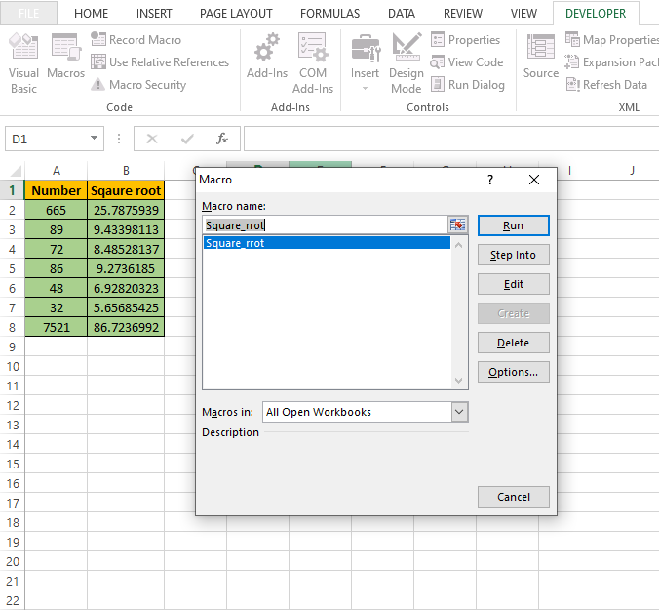

**6. What are the shortcut keys used to**

a. Run the code :- F5

b. Step into the code :- F8

c. Step out of code :- Shift + F8

d. Reset the code :- Ctrl + Break